SEPS Compliance for Log360
Automate SEPS compliance and fortify cybersecurity resilience for financial institutions with Log360.
Region: International | Type: Data Privacy, Financial Services, Industry Standard, Incident Management, Operational Resilience | Category: Compliance | Pricing: Free

Overview
The SEPS compliance extension in Log360 helps organizations meet SEPS Resolution 2022-002 Norma de Control de Seguridad de la Informacion, Ecuador's mandatory ISO 27001-aligned information security norm for financial cooperatives and popular economy entities supervised by SEPS by providing centralized log management, network security monitoring, and automated threat detection. The platform supports SEPS requirements for ISMS governance, access control, audit logging, network security, vulnerability management, incident management, data protection, business continuity, and supplier risk management.
For ISMS Establishment and Security Governance, Log360 monitors policy changes, GPO updates, user account management, and group administration activities to provide governance audit evidence for ISMS compliance. To address Access Control and Authentication Management, the platform monitors user logon activities, MFA events, failed access attempts, and Active Directory changes to enforce and audit access controls across all platforms. The extension also supports Audit Logging and Security Monitoring by providing capabilities that centralizes logs from databases, operating systems, and identity platforms, providing tamper-evident audit records and real-time monitoring for security policy violations.

Key Features
- Network Security and Firewall Management: Log360 monitors network device configuration changes, firewall security events, attack reports, and policy updates to detect unauthorized network access and configuration changes.
- Privileged Access and Administrator Oversight: Log360 monitors administrative logon activity, privilege escalations, and critical system modifications, ensuring strict accountability for high-privileged accounts within the entity's IT environment.
- Incident Detection and Management: Log360 monitors threat detection events, network attacks, and anomalous activities across Windows, Unix, and cloud environments to enable rapid incident detection and regulatory reporting.
- Data Protection and Cryptography Controls: Log360 monitors file access events, USB storage, registry changes, and DLP alerts to detect unauthorized data access or exfiltration attempts.


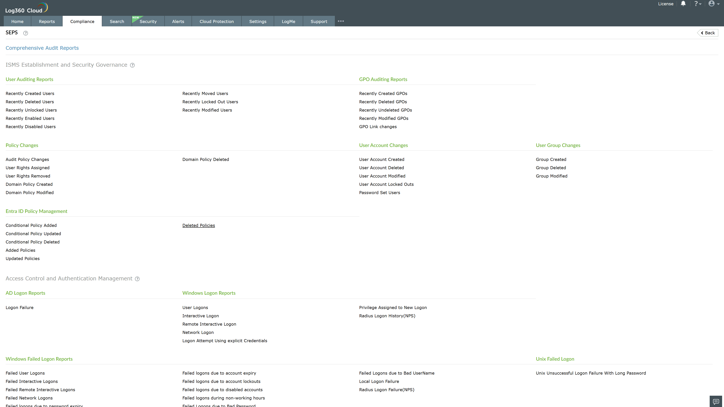
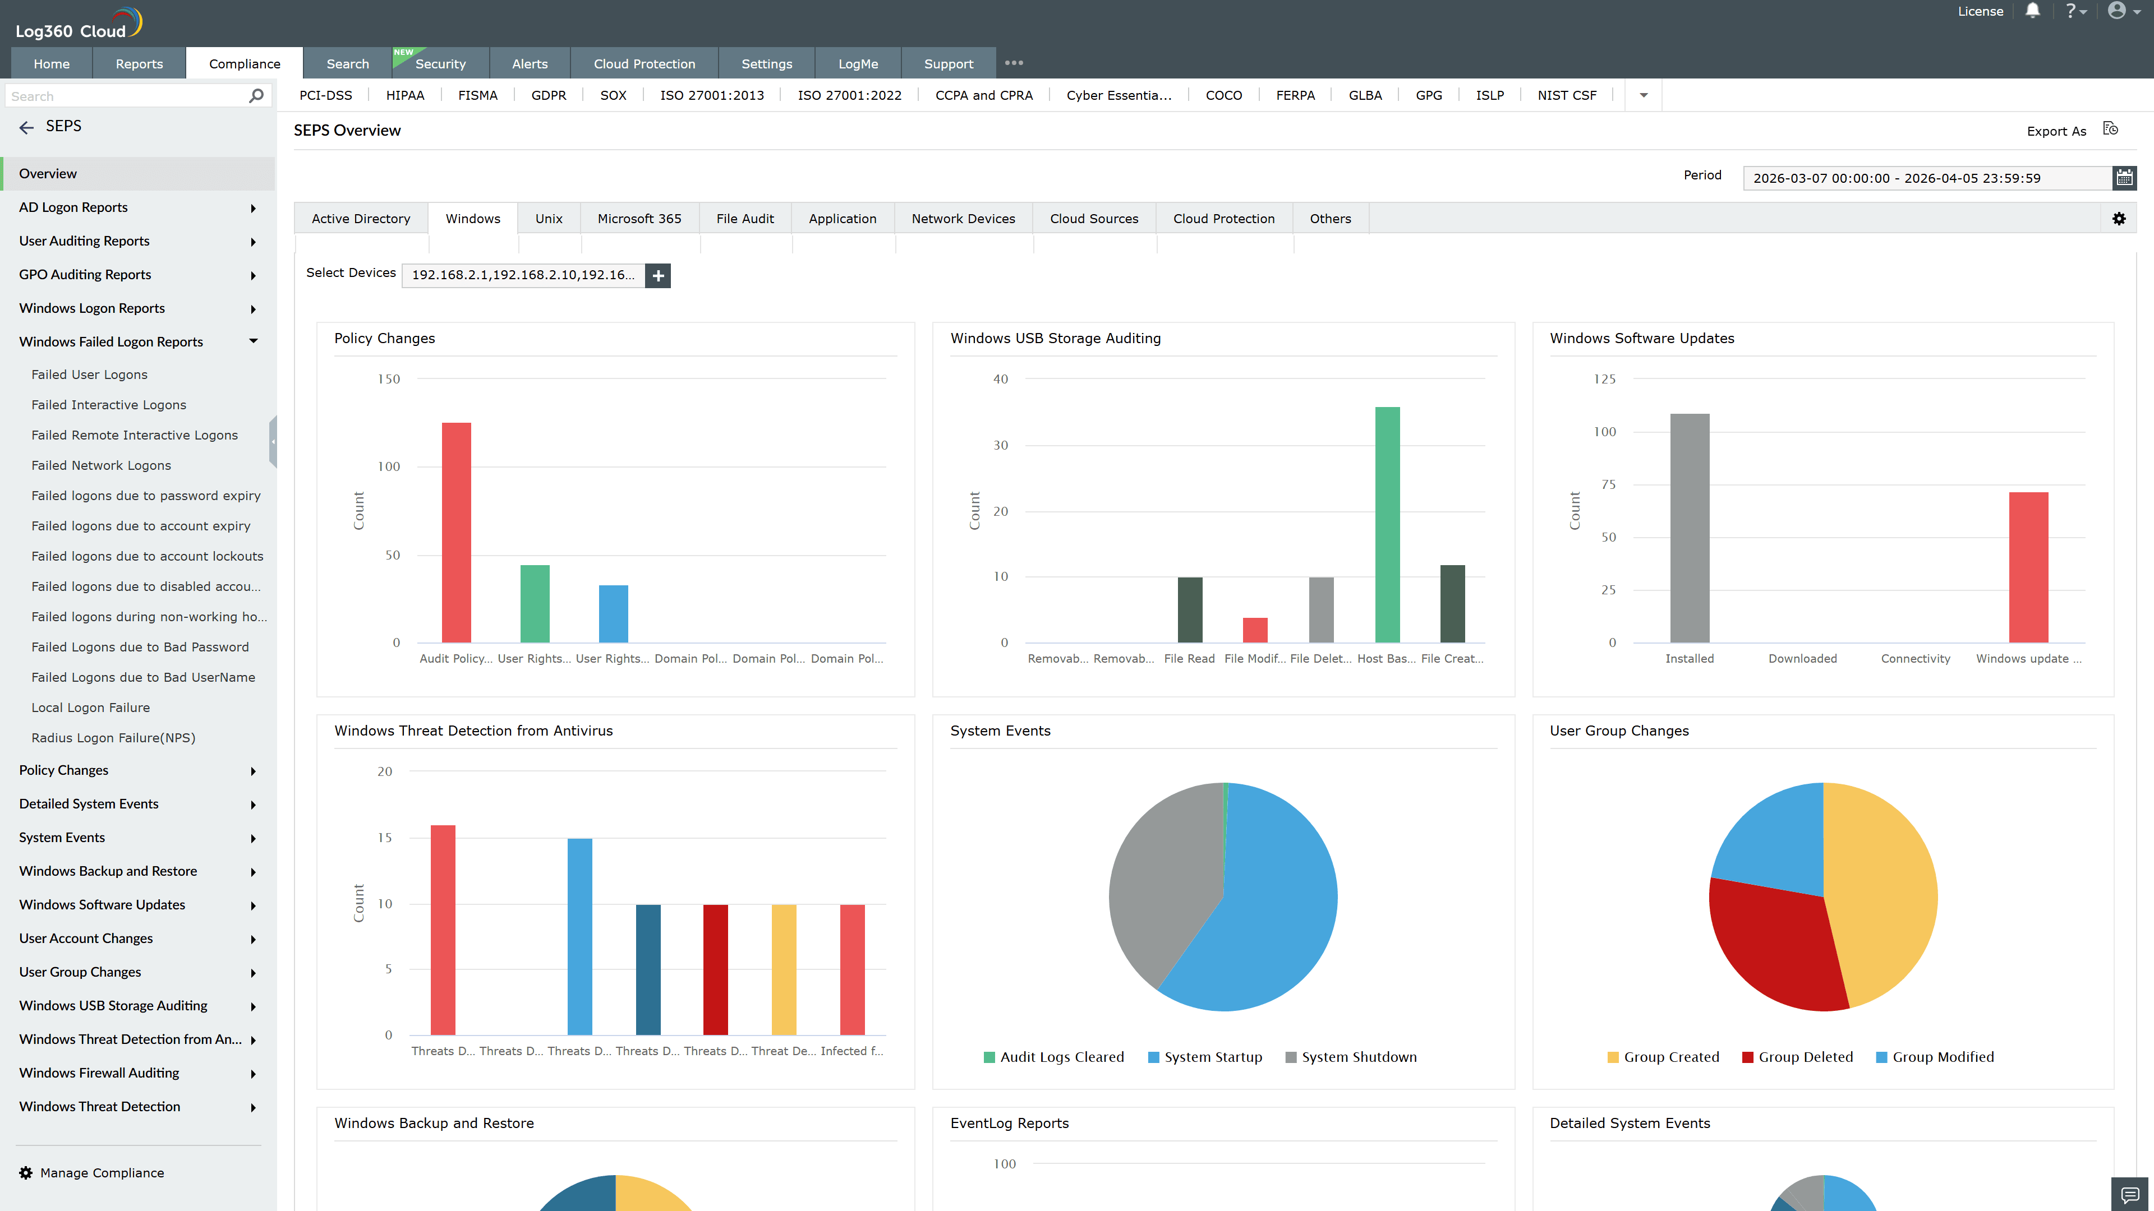
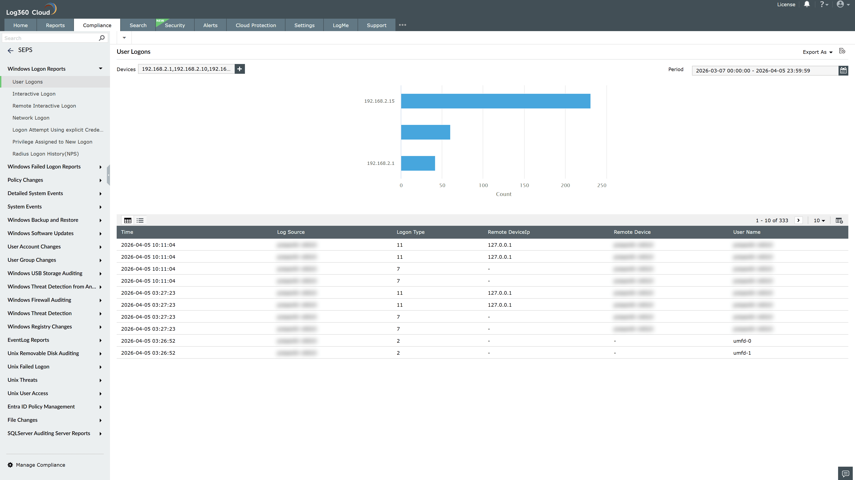
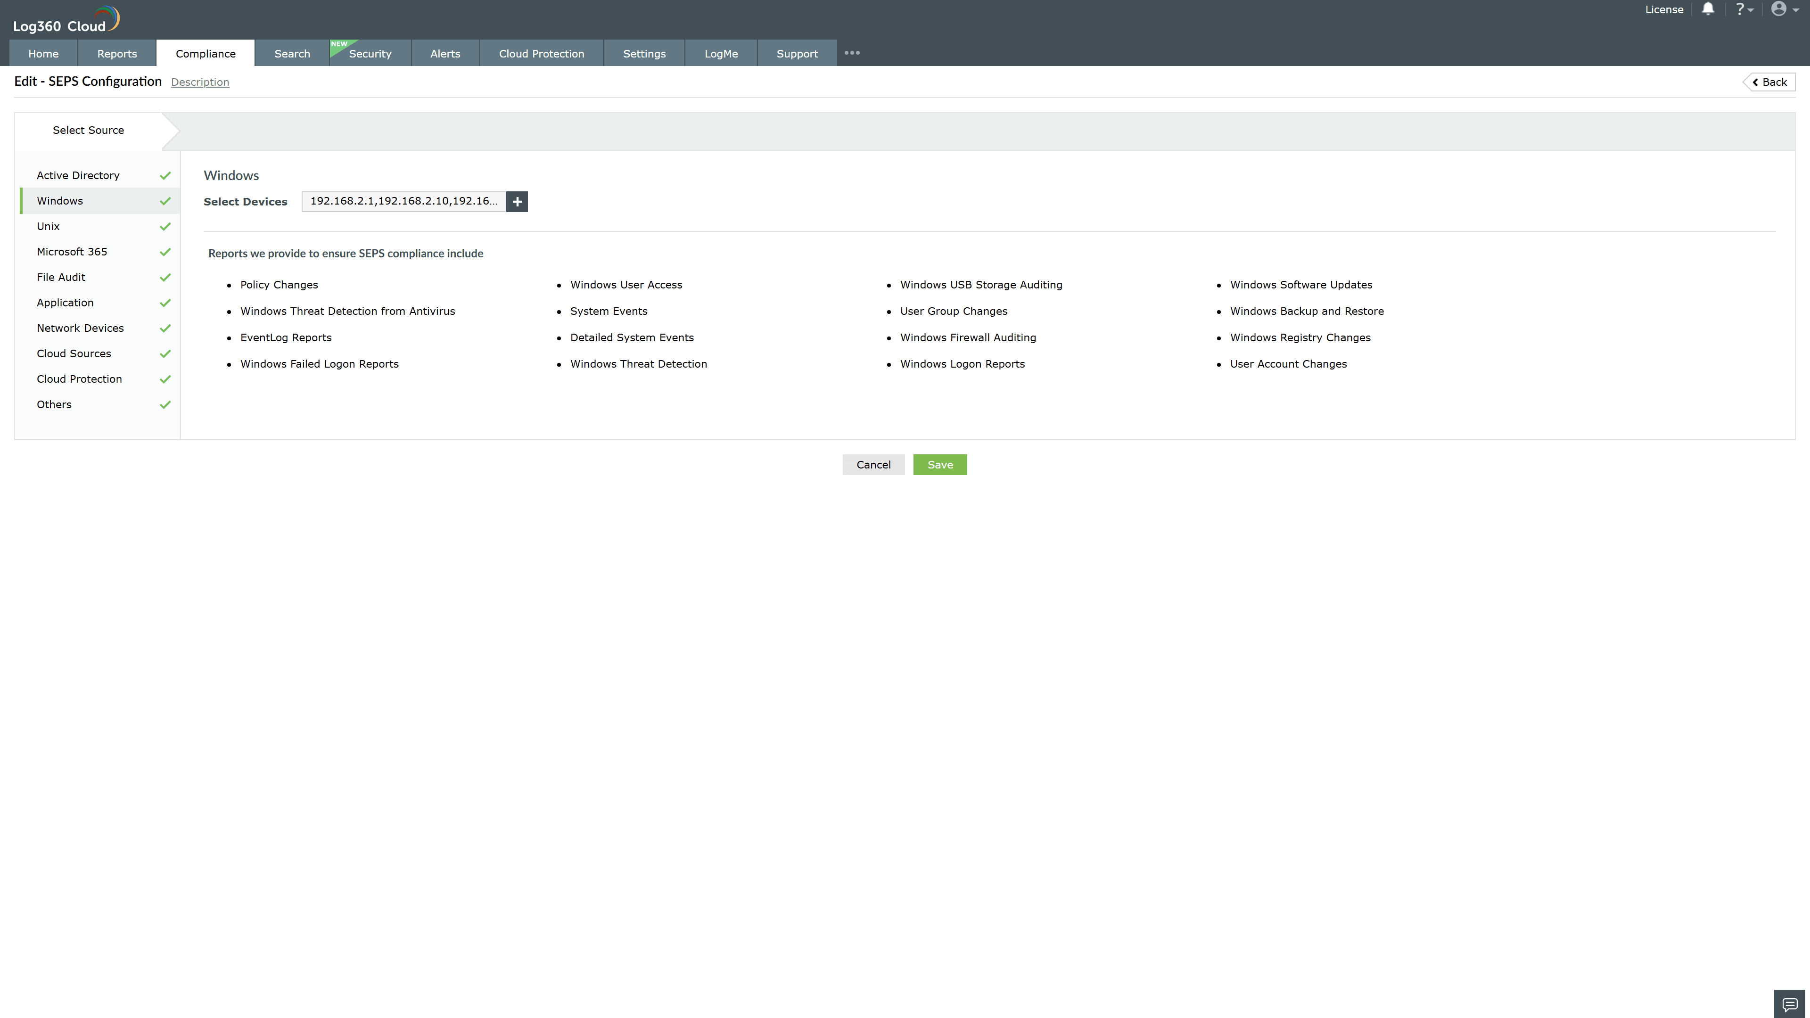
Valid Submission : Yes
Supported Editions : Free, Basic, Standard, Professional, MSSP
Help Document : https://www.manageengine.com/log-management/help/integrations/compliance-extensions.html
Help Video : Not provided
Tags : Log360, Compliance, Privacy monitoring, Data privacy, Regulatory compliance
Supported DCs : US, IN, JP, CA, AU, UK and EU
Privacy Policy:
Terms of Service:
Release Notes:
Predefined reports for the SEPS.

